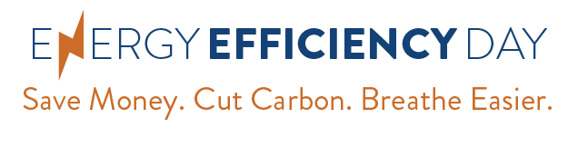
[YOUR LOGO GOES HERE]

MEDIA ADVISORY FOR: Monday, September 16, 2019

CONTACT:
[Name]
[Phone number]
[Email address]
[Org/Company Name] to Urge Consumers to
“Save Money, Cut Carbon, Breathe Easier”
on Energy Efficiency Day 2019
National day of awareness to highlight benefits of energy efficiency

WHAT: On Wednesday, October 2, 2019, [name of org/company] will join a growing network of companies, government agencies, utilities, universities, advocates, and others to showcase the benefits of energy efficiency as part of the 4th annual Energy Efficiency Day (www.energyefficiencyday.org). The message of Energy Efficiency Day is simple: “Save Money. Cut Carbon. Breathe Easier.” Social media content will use the #EEDay2019 hashtag. Cities, counties, and states are officially declaring October 2, 2019, as Energy Efficiency Day with proclamations.

WHEN: Wednesday, October 2, 2019 at [Insert specific time if relevant]

WHERE: [Your org/company’s address where spokespeople will be available for in-person interviews]

WHO: [Name(s) of your org/company key spokespeople available for interviews]
Organizations, companies, government agencies, and others will promote energy efficiency through social media messaging and other activities. The growing list includes states, cities, utility commissions, utilities, government agencies, and companies -- plus a long list of nonprofit advocacy organizations working throughout the country. The full list of the hundreds of organizations supporting Energy Efficiency Day (updated frequently) is available here.

Background: Energy efficiency is the cheapest, quickest way to meet our energy needs, cut consumer bills, and reduce harmful pollution. Energy efficiency is also an economic engine, supporting 2.3 million jobs nationwide in manufacturing, construction and other fields – most of which can’t be outsourced overseas. Energy Efficiency Day is a collaborative effort of regional and national organizations working to promote energy efficiency, including the American Council for an Energy-Efficient Economy (ACEEE), Natural Resources Defense Council, E4TheFuture, Advanced Energy Economy, Regional Energy Efficiency Organizations, Alliance to Save Energy and many others.

To learn more, or find a local energy efficiency success story for Energy Efficiency Day, contact one of the individuals listed below.
###

Organization/Company contacts:
For more information about Energy Efficiency Day, contact:
Amy Konigsburg, Energy Efficiency Day Coordinator, amy@shewolfcommunications.com, 202-577-3862
Maxine Chikumbo, American Council for an Energy-Efficient Economy (ACEEE), mchikumbo@aceee.org, 202-507-4292
Pat Remick, Natural Resources Defense Council (NRDC), premick@nrdc.org, 202-289-2411

