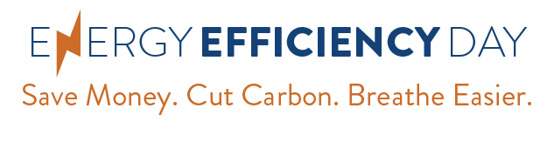
[YOUR LOGO GOES HERE]

FOR IMMEDIATE RELEASE
October 2, 2019

Contact:
[Name]
[Phone number]
[Email address]

[Org/Company Name] to Celebrate Energy Efficiency Day 2019
4th annual national event urging everyone to
“Save Money. Cut Carbon. Breathe Easier.”

[YOUR CITY NAME]— In recognition of the 4th annual national Energy Efficiency Day (EE Day) on Wednesday, October 2, 2019, [name of org/company] is joining regional and national organizations, businesses, utilities, universities, and individuals in promoting energy efficiency – the cheapest, quickest way to meet our energy needs, cut utility bills, and reduce pollution.

Energy efficiency is also an economic engine, with a U.S. workforce of more than 2.3 million. Ranging from professional services to manufacturing and construction, these good jobs are local and cannot be outsourced.

[add a 2-3 sentence quote from org/company leader or spokesperson about why this is important from your perspective], said [PERSON NAME], [JOB TITLE] of [ORG/COMPANY NAME].

Smarter energy use means we don’t have to generate as much power to meet our needs. Many people don’t realize that [org/company name] has already made significant, forward-thinking investments in energy savings, benefiting [health/clean air/consumers/local job growth/local families/utility customers etc.].

[add description of ways your org/company has invested in energy efficiency, using amounts and dollars if possible]

Reducing the energy used by manufacturers, homes, and businesses benefits everyone – especially energy bill-payers. The average household saves almost $500 yearly thanks to efficiency standards that apply to new appliances such as dishwashers, refrigerators and water heaters.

[add another quote from your org/a spokesperson]

To learn more about [org/company name]’s energy efficiency efforts, visit [add your website URL here], or join the Twitter conversation using #EEDay2019

# # #

[ORG/COMPANY MISSION STATEMENT/BRIEF DESCRIPTION HERE: approx. 1-2 sentences]

About #EEDay2019: On Wednesday, October 2, 2019, a growing network of advocates, companies, government agencies, utilities, and others will showcase the benefits of energy efficiency during the 4th annual nationwide Energy Efficiency Day. Learn more at www.energyefficiencyday.org

